GUVI TASK

ADVANCE JAVA

Q1. Write a program to check whether the Strings in the List are empty or not and print the list having non-empty strings. If the given List is: Liststrings = Arrays.asList("abc", "", "be", "efg", "abcd","", "jkl");

PROGRAM:

package AdvanceJava;  
  
import java.util.ArrayList;  
import java.util.Arrays;  
import java.util.List;  
import java.util.function.Predicate;  
  
import static java.util.Locale.*filter*;  
  
public class Demo1 {  
 public static void main(String[] args){  
 List<String> list = Arrays.*asList*("abc", "", "be", "efg", "abcd", "", "jkl");  
  
 Predicate<String> predicate =(s) -> !s.isEmpty();  
  
 // using for each loop passing the input to the predicate.And storing nonEmptyString in the new arrayList.  
  
// List<String> nonEmptyString = new ArrayList<>();  
// for(String l:list){  
// if( predicate.test(l)){  
// nonEmptyString.add(l);  
// }  
// }  
 // iterating string in the input list and filtering through the predicate.  
 List<String> nonEmptyString =list.stream().filter(predicate).toList();  
  
 System.*out*.println(nonEmptyString);  
 }  
}

OUTPUT:

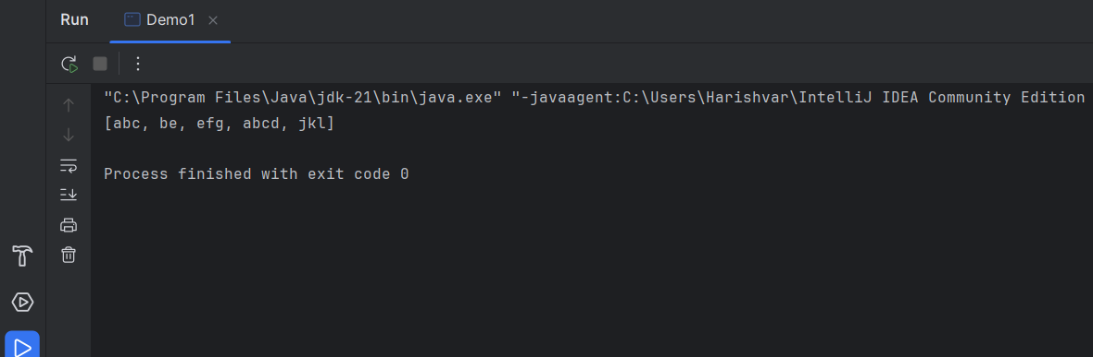

Q2. write a program using map() method,to convert a list of strings into uppercase.  
If the given List is:Stream names =Stream.of("aBc","d","ef");

PROGRAM :

package AdvanceJava;  
  
//write a program using map() method,to convert a list of strings into uppercase.  
// If the given List is:Stream names =Stream.of("aBc","d","ef");  
  
  
import java.util.ArrayList;  
import java.util.List;  
import java.util.function.Function;  
import java.util.stream.Collector;  
import java.util.stream.Stream;  
  
  
  
public class Demo2 {  
 public static void main(String[] args){  
 Stream<String> names = Stream.*of*("aBc","d","ef");  
 Function<String,String> function = (s) ->s.toUpperCase();  
 List<String> list =names.map(function).toList();  
  
 System.*out*.println(list);  
 }  
}  
  
OUTPUT:

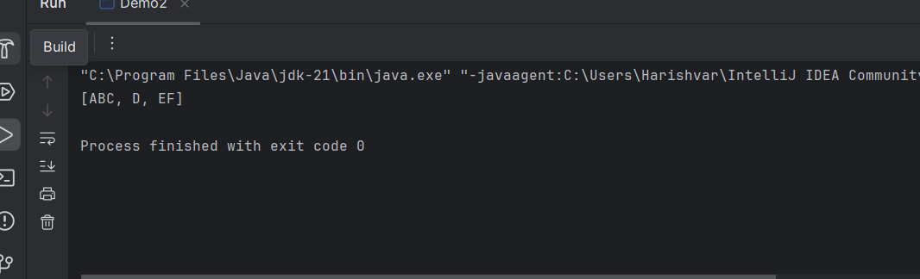

Q3. //You are a teacher in school In your class there are 10 students, you have decided to give special gifts to those students whose names start with "A".  
// you are asked to separate those students with the help of a java program.  
//Requirement:  
//Use List interface to store the student name  
//Use a lambda expression and the Stream API to filter the students  
  
PROGRAM:

package AdvanceJava;  
  
import java.util.\*;  
import java.util.function.Function;  
import java.util.function.Predicate;  
  
//You are a teacher in school In your class there are 10 students, you have decided to give special gifts to those students whose names start with "A".  
// you are asked to separate those students with the help of a java program.  
//Requirement:  
//Use List interface to store the student name  
//Use a lambda expression and the Stream API to filter the students  
public class Demo3 {  
public static void main(String[] args){  
 Scanner sc = new Scanner(System.*in*);  
 List<String> names = new ArrayList<>();  
 for(int i = 0;i < 10;i++){  
 //String s = sc.nextLine();  
 names.add(sc.nextLine());  
 }  
 System.*out*.println(names);  
 Predicate<String> predicate = (s) -> s.startsWith("a");  
 List<String> specialList = names.stream().filter(predicate).toList();  
 System.*out*.println(specialList);  
  
}  
  
}

OUTPUT:

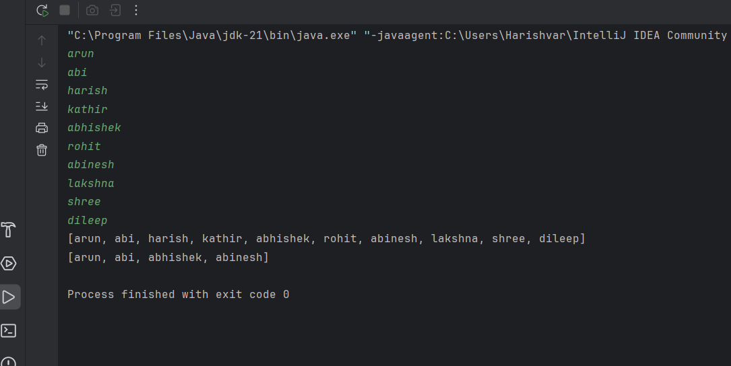

Q4.

PROGRAM:

package AdvanceJava;  
  
import java.time.LocalDate;  
import java.time.Period;  
import java.util.Scanner;  
  
public class Demo4 {  
 public static void main(String[] args) {  
 Scanner scanner = new Scanner(System.*in*);  
  
 // Input from user  
 System.*out*.print("Enter your birthdate (yyyy-mm-dd): ");  
 String input = scanner.nextLine();  
  
 // Parse birthdate and get current date  
 LocalDate birthDate = LocalDate.*parse*(input);  
 LocalDate currentDate = LocalDate.*now*();  
  
 // Calculate the period between dates  
 Period age = Period.*between*(birthDate, currentDate);  
  
 // Output the result  
 System.*out*.printf("Your age is: %d years, %d months, and %d days.%n",  
 age.getYears(), age.getMonths(), age.getDays());  
 }  
}

OUTPUT:

